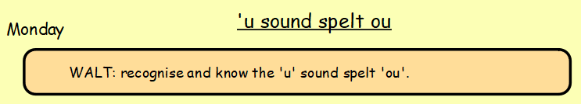

Look at the words below, read each one and listen out for how the ‘u’ sound is spelt ou. Then, group the words in a way of your choice and explain your reasoning.
*Tip: look carefully at the spelling of each word.
Once you have done that, pick 5 words and write 5 sentences, each sentence must contain one of your chosen words.
*Challenge: how many of the words below can you get into one sentence? Re-read your sentences to check they make sense!
young touch plough
cousin tough dough
double rough could
trouble should touch
couple through though
country would enough
thought although

