Pyramids Fact Sheet
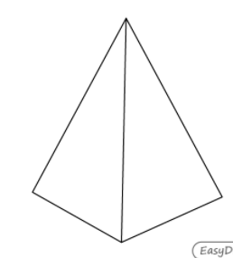
What I know about pyramids

