It is recommended that you try to raise your heart rate for **at least** 30 minutes each day. Here are some of our suggestions to help you do that!

Daily Activity Menu

Joe Wicks Session

For those feeling energetic or with some energy to burn! Joe Wicks daily sessions are back! YouTube channel, free to subscribe.

<https://www.youtube.com/results?search_query=joe+wicks+pe+lessons+live>

SUPERMOVERS

<https://www.bbc.co.uk/teach/supermovers>

Movement linked with other learning too! Great for practising math facts!

GoNoodle

<https://app.gonoodle.com/>

Great dances and workouts that the kids love. You can also access on YouTube!

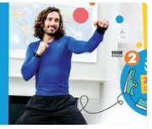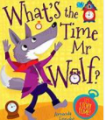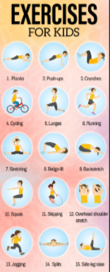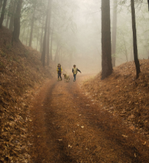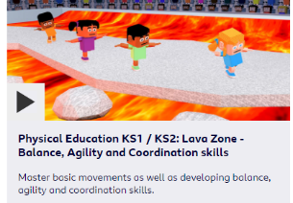

*Pelynt Primary Academy 2021*

Play games and have fun!

* Simon Says
* What’s the time Mr Wolf?
* Ball skills
* Bike rides
* Assault courses etc…

We’d love to hear of ideas you would recommend!

BBC- Let’s Get Active

<https://www.bbc.co.uk/teach/class-clips-video/physical-education-ks1-ks2-lets-get-active/z72yjhv>

Great for developing key skills and tactics!

Family walk as part of your daily exercise!

Make sure you get plenty of fresh air!

Imoves Active Home Learning Hub

Access ‘imoves’ active home learning hub using our unique ID and password.

ID: 1700 Password: fly

<https://platform5.imoves.com/hl>

Online PE lessons

<https://www.afpe.org.uk/physical-education/thisispe-supporting-parents-to-teach-pe-at-home/>

More great activity ideas!

Arena P.E YouTube Channel

<https://www.youtube.com/channel/UCCStjKlMICO-Em7zMJoHR3A/featured?disable_polymer=1>

Our PE provider’s YouTube channel!

Create your own Circuit Challenge –

Cosmic Yoga

<https://www.youtube.com/results?search_query=cosmic+yoga>

Free to subscribe YouTube channel!

The PE Shed

<https://www.thepeshed.com/>

Ideal for mini games and working on skills!