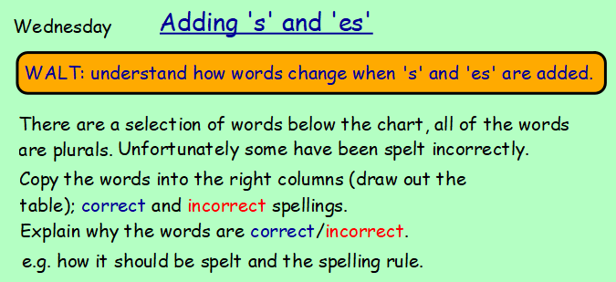
Correct |  | Incorrect
Word | Reason | Word | Reason

