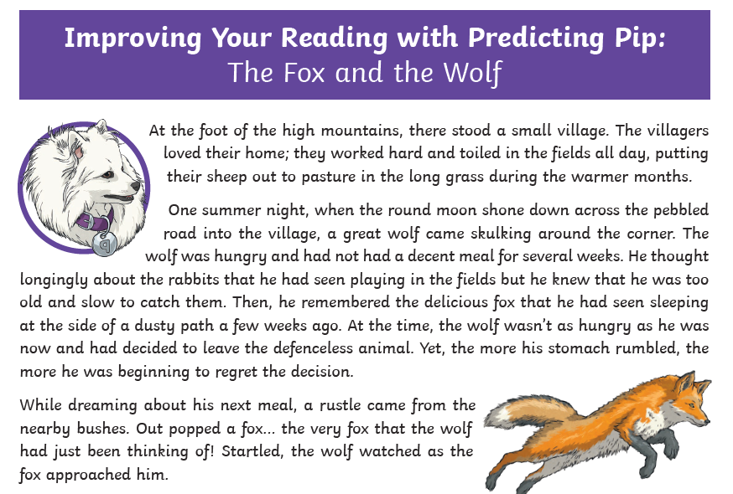
If you were in our TEAMS session today, you will have heard the text being read and followed along yourself. Your task is to read the text again and answer the following questions.
Write down the question number and then your answers.
