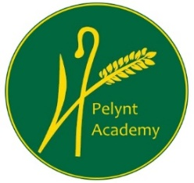
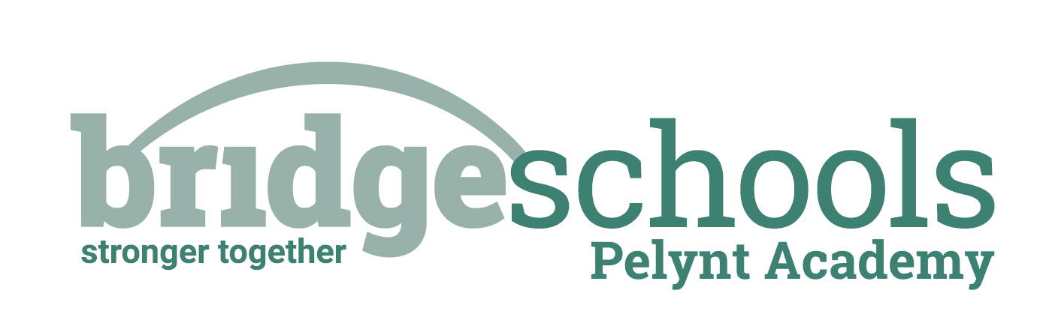
Pelynt Academy
Pelynt,
Looe,
Cornwall, PL13 2LG
Tel: 01503 220262
www.pelyntprimaryschool.co.uk
secretary@pelyntprimary.co.uk

Wednesday 20th January 2021

Maths:
YEAR 1: This week is Spring week 3: Number, addition and subtraction. Children will be working with numbers up to 20. Please watch the ‘subtraction not crossing 10’ video below and complete the attached Y1 maths worksheet.
https://whiterosemaths.com/homelearning/year-1/spring-week-3/

YEAR 2: Please follow the link below to watch the video, ‘redistribute from equal to unequal groups’. Using Y2 maths cards and Y2 maths groups, cut up the cards to see if the children can match the pictures with the words.
https://whiterosemaths.com/homelearning/year-2/week-12-number-multiplication-division/
Keep using tt rockstars to practice your times tables.

Phonics/Reading:
Year 1: Follow the link for the Year 1 phonics lesson. Today’s lesson is Year 1 Spring Term lesson 11 – le bubble.
https://www.youtube.com/watch?v=S2vdHpxk0TI
Practice the next page of your handwriting booklet.
Year 2:
Today we are learning to spell words containing ness, ment, ful and less. Watch the youtube video link below which discussed ingredients for friendship soup. (The children are already familiar with this). Write a list of ingredients that you would include in friendship soup. EG: a spoonful of happiness.
https://www.youtube.com/watch?v=H7w7yXkJTu0
Both year groups, try to practice reading to an adult for at least 10 mins every day. See the reading websites below to try something new.
Practice your ‘teach your monster to read’.

Topic:

Continue to work from ‘The Day the Crayons Quit’ topic grid. This is our final week where we will be following this grid.

Don’t feel that you need to complete all of the activities. Do what you can and have fun!

Be active: Choose an activity from the daily activity menu on Monday’s blog and get your heart rate up for 30 minutes.

Website hyperlinks to access reading resources:
https://library.thenational.academy/

https://www.vooks.com/

https://www.bbc.co.uk/bitesize/subjects/zgkw2hv

https://home.oxfordowl.co.uk/reading/free-ebooks/

Free Kid's eBooks and NOOK Books | Barnes & Noble® (barnesandnoble.com)

Phonics Games for the Classroom and Home - Phonics Bloom

