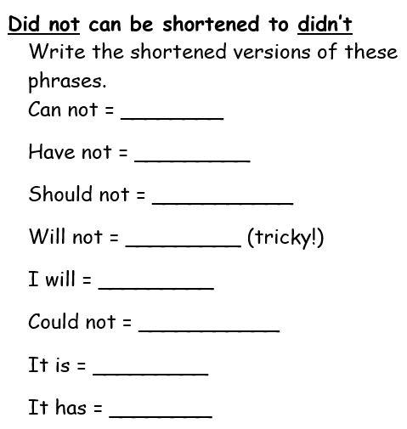
Task 1

Task 2
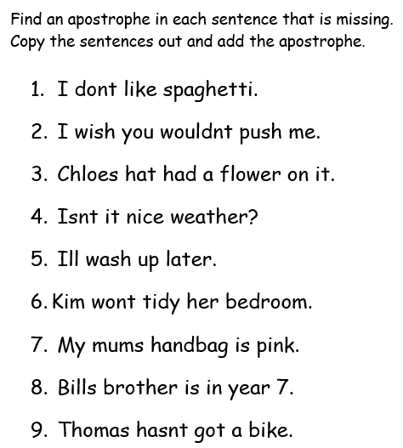

Task 3
Choose your own level of challenge (1* or 2*). Write the sentences out and change any underlined words into their contracted form. Use the word bank at the bottom to help you.
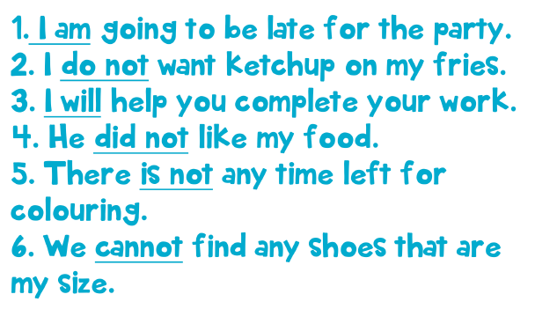
*

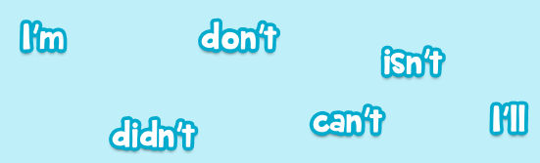

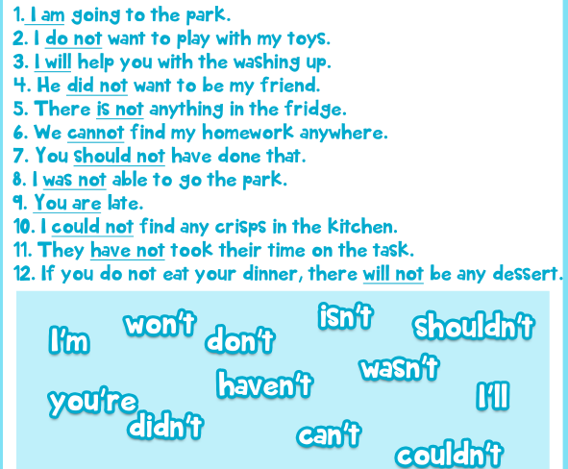
**

Task 4
Write three of your own sentences using some of the contracted words you have learnt about today.
*Challenge: add in pronouns, a prepositional phrase and a conjunction*

