Homework spelling Challenge!
On our class blog you have been given a list of spelling words to learn over the next week.
Here are some activities that you could do at home, to help you to remember how to read, understand and spell these words. Tick, colour in or draw a picture in the box, every time you complete an activity.
Make some of your spelling words out of play dough.  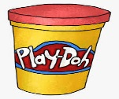 | Say the letters to spell one of your words over and over again.  h a v e | Write some of your spellings in sand or rice.  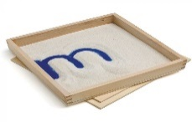 | Make a mnemonic for some of your spellings. EG; two = two wet oranges | Make up an action for each letter to spell your word. (Think YMCA)
Colour in the trickiest parts of your words.  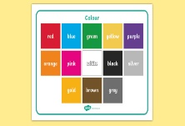 | Write your spellings using glitter and glue.  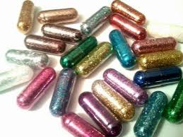 | Create a piece of art work for one of your spellings. Put it on the wall to help you remember it.  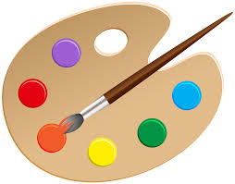 | Write sound buttons underneath the letters in your words. | Draw a tree. Write each of your spelling words on one of the branches.
Write a poem which contains some of your spelling words. | If you have letter stickers or stamps, use them to write some of your words.  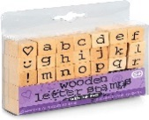 | Write some of your spelling words and colour in the consonants.  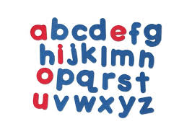 | Write out some of your spelling words in order of how many letters they contain. | Make a game of snap with some of your spelling words.  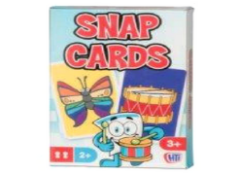
If you have an ipad, download the free app ‘spellasuar’ and ask grown up to type in some of your spelling words. | Make some of your words using objects such as pasta, paper clips or leaves.  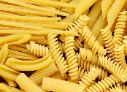 | Make up a rhyme containing as many of your spellings as you can.  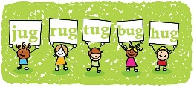 | Clap the syllables in some of your spelling words. | Play hangman with some of your spellings.  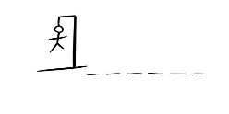
Please try to complete at least 1 activity per week. There will be special certificates for those children who are completing plenty of challenges.

