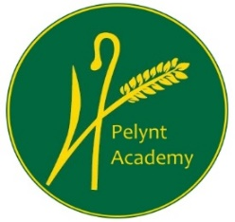
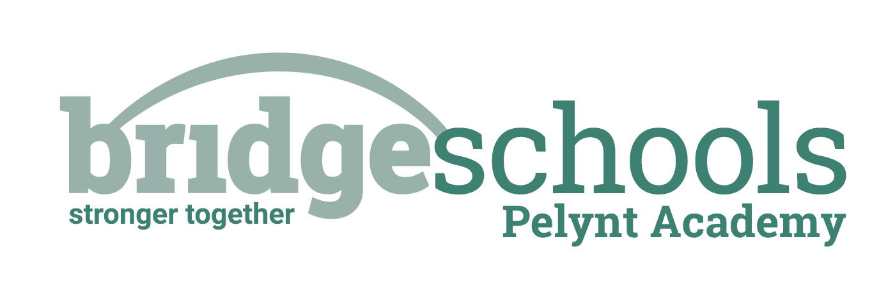
Pelynt Academy
Pelynt,
Looe,
Cornwall, PL13 2LG
Tel: 01503 220262
www.pelyntprimaryschool.co.uk
secretary@pelyntprimary.co.uk

Friday 22nd January 2021

Maths:
YEAR 1: This week is Spring week 3: Number, addition and subtraction. Children will be working with numbers up to 20. Please watch the second ‘counting back’ video below and complete the attached Y1 maths worksheet.
https://whiterosemaths.com/homelearning/year-1/spring-week-3/

YEAR 2: Please follow the link below to watch the video, ‘Make arrays’. Complete the Year 2 maths worksheet. When the children are making their own arrays, you may find it helpful to use bun tins, or egg boxes, so that they can easily place objects in the compartments. (This will make sense when you look at the worksheet).
https://whiterosemaths.com/homelearning/year-2/week-12-number-multiplication-division/
Keep using tt rockstars to practice your times tables.

Phonics/Reading:
Year 1: Follow the link for the Year 1 phonics lesson. Today’s lesson is Year 1 Spring Term lesson 13 – c mice
https://www.youtube.com/watch?v=7Kk2PcAUYME
Practice the next page of your handwriting booklet.
Year 2:
If anyone would like to collect their child’s homework book from school, I have left them in the school entrance for you. Choose some activities from the spelling activity grid to help you to learn the spellings; many, clothes, busy, people, water, again, half, money, Mr, Mrs. These spellings would have been the next set that we would have been learning in school.
Both year groups, try to practice reading to an adult for at least 10 mins every day. See the reading websites below to try something new.
Practice your ‘teach your monster to read’.

Topic:

Continue to work from ‘The Day the Crayons Quit’ topic grid. This is our final week where we will be following this grid.

Don’t feel that you need to complete all of the activities. Do what you can and have fun!

Be active: Choose an activity from the daily activity menu on Monday’s blog and get your heart rate up for 30 minutes.

Website hyperlinks to access reading resources:
https://library.thenational.academy/

https://www.vooks.com/

https://www.bbc.co.uk/bitesize/subjects/zgkw2hv

https://home.oxfordowl.co.uk/reading/free-ebooks/

Free Kid's eBooks and NOOK Books | Barnes & Noble® (barnesandnoble.com)

Phonics Games for the Classroom and Home - Phonics Bloom

