Homework spelling Challenge!
Use these activities to help you to learn the spellings from your spelling list. It might be easier to focus on between 5 and 10 words per week. Do several activities for each word that you learn, that way you are more likely to remember how to spell the word.

Choose some of your spelling words. How many times can you spot these words in a book? | Write your spellings forwards and backwards. | Use magnetic letters to write your spelling words. | Cut letters out of newspapers or magazines to spell some of your words. | Write your spellings in a pyramid. EG:  S  So  Som  S o m e
Write your spellings outside with chalk. | Use a squirty bottle filled with water to write your spellings outside. | Write some of your spellings in sentences. | How many of your spellings can you fit into one sentence? | Draw a big flower. Write each of your spelling words on one of the petals.
Write a story which contains some of your spelling words. | 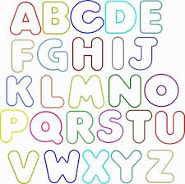  Write your spellings in bubble letters and colour them in. | Write some of your spelling words and trace over the vowels in a coloured pencil. | 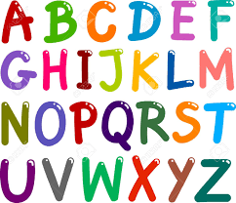  Write out some of your spelling words in alphabetical order. | 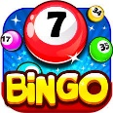  Play bingo with some of your spelling words.
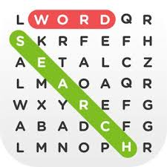  Make a word search containing some of your spellings. | Write some of your spellings using small objects such as leaves or paper clips.  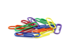 | 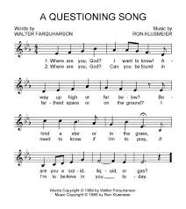  Make up a song containing as many of your spellings as you can. | 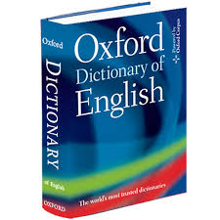  Find out the meaning of some of your spellings using a dictionary. | Make an anagram of some of your spellings for a family member to solve.
Your teacher will be looking to see you spelling these words correctly in your own writing when you are at school.

