Task 1
Copy out these sentences and add the inverted commas where they need to go.
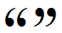
- Hello, said the man.
- What are you doing? said Fred.
- Stop! shouted the policeman.
- Wait a minute, said Mark. Don’t I know you from somewhere?
- I know what we’ll do, said Lucy. We’ll go to the pictures.

Task 2
Copy out these sentences and add in the correct punctuation marks – full stops, commas, question marks, exclamation marks and inverted commas.
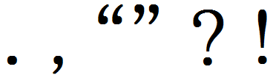
1. Bye said Greg
2. Can I come in asked the man
3. No screamed the man
4. Is that my bag asked Daniel I thought I’d lost it
5. Run shouted Sally The dog is after us

Task 3
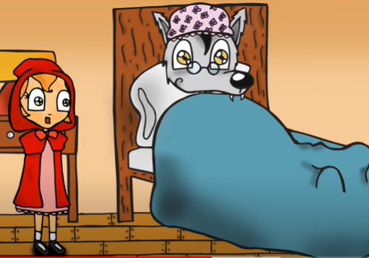
You are all familiar with the story of Little Red Riding Hood. Your task is to show your understanding of inverted commas by writing a conversation between Little Red Riding Hood and the wolf when he is dressed up as Granny in Granny’s bed. Here is a link to the audio story (5 minutes) if you want a reminder of what gets said at that point in the story: https://youtu.be/1R8eSy38P7M

