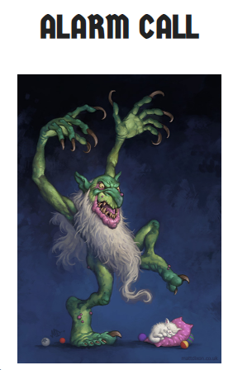

This is a task to build upon our TEAMS session on Wednesday where we were focusing on our prediction skills in reading. Write down your answers to the following questions.
**Remember to back up your statement with a reason/evidence from what you can see**

- What kind of monster is this?
- What do you think the kitten is dreaming of?
- What is the monster going to do?
- What do you think will happen next?

Now, write the opening paragraph of the story, make sure you add description and try to add in some of the aspects you have learnt about this week during English; pronouns, subordinating conjunctions, inverted commas and apostrophes for contractions.
**Send me a photograph of your opening paragraph through TEAMS or via email. I look forward to reading them!

