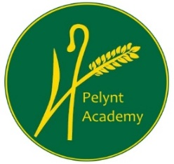
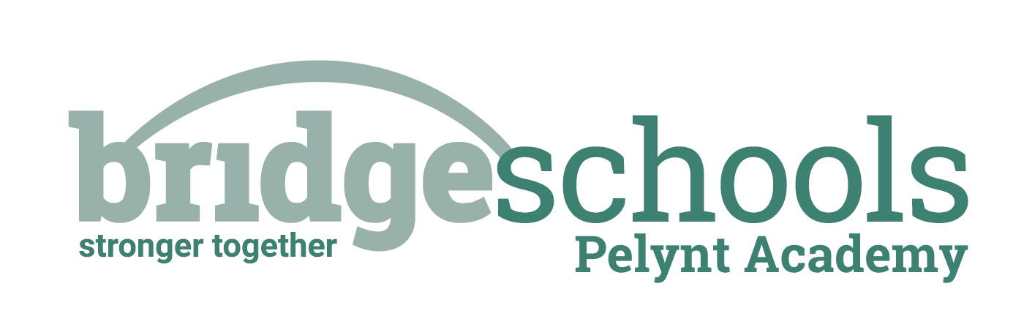
Pelynt Academy
Pelynt,
Looe,
Cornwall, PL13 2LG
Tel: 01503 220262
www.pelyntprimaryschool.co.uk
secretary@pelyntprimary.co.uk

Monday 25th January 2021
Maths:
YEAR 1: This week is Spring week 4: Number, addition and subtraction within 20. Please watch the ‘subtraction. Crossing 10-1’ video below and complete the attached Y1 maths worksheet.
https://whiterosemaths.com/homelearning/year-1/spring-week-4-number-addition-and-subtraction-within-20/

YEAR 2: This week, we are following the white rose, ‘Spring Week 1, multiplication and division’ unit. Please watch the first video ‘recognise equal groups’ by following the link below. Complete the Y2 worksheet in the attatchment.
https://whiterosemaths.com/homelearning/year-2/week-1-number-multiplication-and-division/
Keep using tt rockstars to practice your times tables.

Phonics/Reading:
Year 1: Follow the link for the Year 1 phonics lesson. Today’s lesson is Year 1 Spring Term lesson 14 – g giant
https://www.youtube.com/watch?v=Rxod5qc3AhY
Practice the next page of your handwriting booklet.
Complete the Year 1 reading task in the attachments.
Year 2:
Choose some activities from the spelling activity grid to help you to learn the spellings; many, clothes, busy, people, water, again, half, money, Mr, Mrs. These spellings would have been the next set that we would have been learning in school.
Complete the Year 2 reading task.
Both year groups, try to practice reading to an adult for at least 10 mins every day. See the reading websites below to try something new.
Practice your ‘teach your monster to read’.

Topic:

Our Home Learning for the next two weeks is all about the poem ‘My Hat!’ by Tony Mitton. You can find more poems by Tony in his books ‘Plum’ and ‘Come into this Poem’.

Be active: Choose an activity from the daily activity menu and get your heart rate up for 30 minutes.

Website hyperlinks to access reading resources:
https://library.thenational.academy/

https://www.vooks.com/

https://www.bbc.co.uk/bitesize/subjects/zgkw2hv

https://home.oxfordowl.co.uk/reading/free-ebooks/

Free Kid's eBooks and NOOK Books | Barnes & Noble® (barnesandnoble.com)

Phonics Games for the Classroom and Home - Phonics Bloom

