Monday 25th January 2021
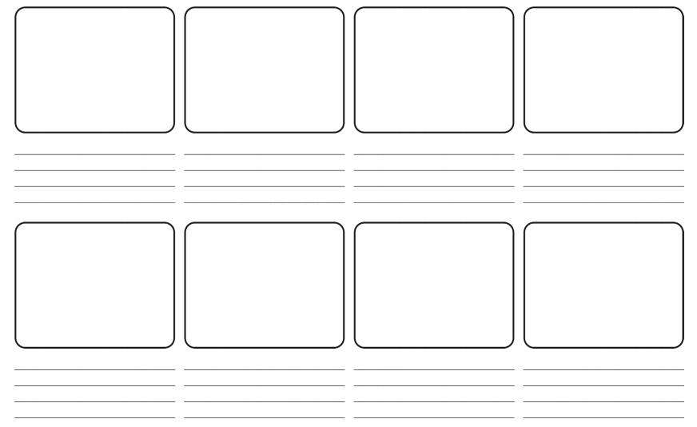
Create a storyboard for the tale of Theseus and the Minotaur.

