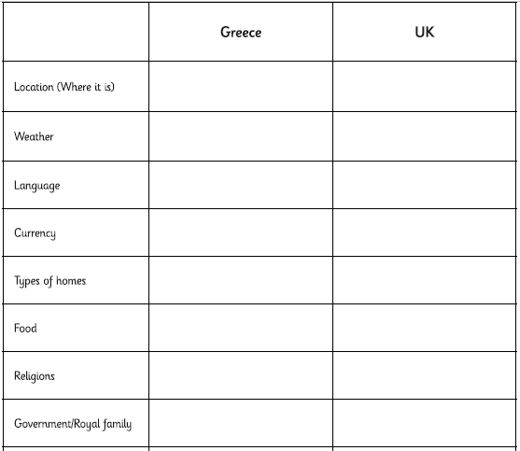
You are going to be comparing Greece to the UK. Use the internet to research the items listed on the left and then record your information in your own table (use the one below as a guide).

