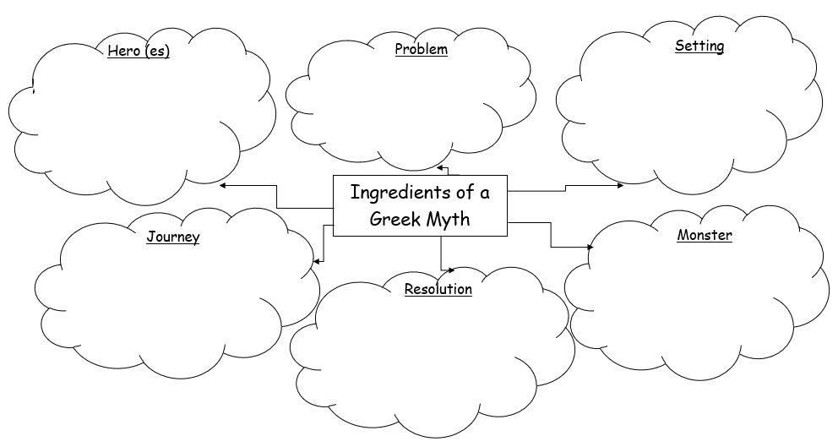
Tasks:
- Read two of the Greek myths. 2. Identify and record the features in a mind map/ a way of your choice.

