

Pelynt Academy  
Pelynt,  
Looe,   
Cornwall, PL13 2LG  
Tel: 01503 220262  
www.pelyntprimaryschool.co.uk  
secretary@pelyntprimary.co.uk

Home Learning for **Reception** Class 1, weeks beginning 25th Jan and 1st Feb 2021

Our Home Learning for the next two weeks is all about the poem ‘Big Red Boots’ by Tony Mitton.

Find out more about Tony on his website: <http://www.tonymitton.co.uk/>

You will find clips of him reading his poems there too.

**Big Red Boots**

Big red boots, big red boots.

One of them squeaks and the other one toots.

One of them hops and the other one stamps.

Big wet boots take long, wet tramps.

Boots, boots, big red boots.

One of them squeaks and the other one toots.

Big red boots on busy little feet

start out shiny, clean and neat.

Big red boots oh yes, yes, yes,

end up muddy in a terrible mess.

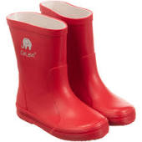 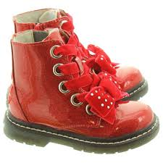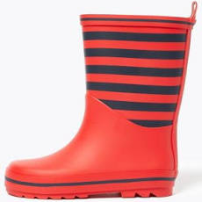 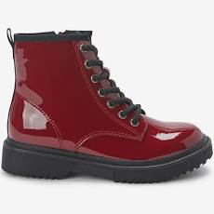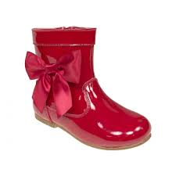 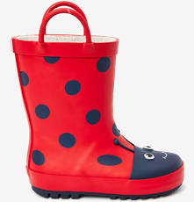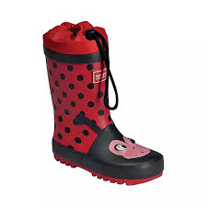

Boots, boots, big red boots.

One of them squeaks and the other one toots.

Boots, boots, big red boots,

squelch through mud and trample roots.

Big red boots say, “Look! Oh gosh!

What a great puddle there... Yay! SPLOSH!”

**About this poem (info for grown-ups):**

This is a joyous, punchy, rhythmic poem. Children will love speaking it and moving to it. It is a poem to take outdoors and use as a marching rhyme and one we recommend to parents as a way of keeping little ones on the move!

**Technical aspects:**

The punchy feel to this poem is achieved by:

* the **alliterative** ‘b’ sounds in *boots, big, busy* which they can enjoy on their lips
* the use of mostly **single syllable** words
* the **chorus repetition**
* the 4-beat **rhythm**
* the use of **rhyme**
* the poem also uses **onomatopoeia e.g*.*** *toot, squeak, splosh, squelch*

You do not need to use these terms with the children at this age.



I

Below is a grid containing Literacy based activities about the poem. We have planned these activities to take place over the next two weeks. Please don’t worry if an activity takes more than one day or if your child takes the learning activity in a different direction; the focus for this learning is mainly speaking, listening and extending the children’s vocabulary. Share the poem every day and then encourage them to undertake some of the activities in the grid (one a day would be good, but as many as you can do is fine). We have attached the ‘Big Red Boots’ poem in a Word document in the blog so you can print it and have it available to refer back to each day.

After the Literacy based grid there is another grid with activities covering the other areas of learning for Reception. We suggest you pick a variety of activities from each area of learning across the two weeks. As always, you can of course think of some of your own activities if you would like to.

If you have any questions, please do not hesitate to contact me: [**jwakeham@pelyntprimary.co.uk**](mailto:jwakeham@pelyntprimary.co.uk)

**Please remember to send me photographs of your home learning or if anything is on paper, keep it safe to hand in at half term**.

**Literacy Learning Grid 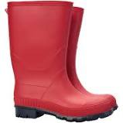      **

|  |  |
| --- | --- |
| **Remember that you have your sound mat to help you sound out to spell words for any written work you do.** | |
| **Activity 1.** Read the poem together outdoors, with everyone wearing boots if possible.  What colour are your boots? Do you like splashing in puddles/ jumping in mud/ kicking up leaves in your boots? Talk about why boots are good to wear in mud, in puddles, when kicking up leaves.  Discuss the words used with a grown-up. Do you know what all the words mean?  First learn the chorus and then try to learn the whole poem. | **Activity 2.** Perform the poem again with instruments. For example: a drum or a saucepan and wooden spoon to mark a steady pulse. (You may want to use an instrument you have made- see the grid below)  Keep practicing the words of your poem, along with the rhythm of your instrument.  **Mrs Wakeham would love to see a video of you performing the poem!** |
| **Activity 3.** Either outdoors or indoors, put on real or imaginary boots and investigate how you can **move** in different ways – *walk, march, stamp, hop, leap, run, jump.*  Play **Follow my Leader** games – take it in turns to be the leader. Can you think of any other ways to move with your boots on? | **Activity 4.** Read the poem again and leave out the rhyming words at the end of each second line – can your child fill in the gaps? Can they think of other rhyming words to go with them? (see the attached rhyming boots sheet to help). Adults – please write down the rhyming words which your child thinks of.  ***boots – toots – roots -? stamps – tramps -?***  ***feet – neat -? yes – mess -?***  ***gosh – splosh -?*** |
| **Activity 5.** Talk about the onomatopoeic words such as *squeak, toot, squelch, splosh.* Can you think of anymore? *For example: splash, ooze, crash, bang.* Make sure that your child knows what these words mean. Take a look at the attached Onomatopoeia Poster for ideas and you could make your own small poster by drawing a picture for each new word you think of. | **Activity 6.** Talk about where you have been in your wellies and then list the **places** you have visited. Talk about them with a grown up and then take a look at the Teddy goes on a Welly Walk sheet and draw a picture map of the places you have been with your grown-ups when wearing your boots. For example:  o*ut of my front door, down the garden path, all along the lane.* |
| **Activity 7.** Imagine you could design your own dream boots – talk about what they would look like, what they could do (they could do magical things) and where you would go. Draw and label these special boots or use the attached design sheet. Talk about the adventure that the boots could have. An adult could record/video your ideas. | **Activity 8.** Wash your boots together. Talk about what you need and the order in which you need to do it. Can you draw pictures or take photos and put them in order? You could write a ‘What you need’ list too, to make a set of instructions for cleaning muddy boots using pictures and words. |
| **Activity 9.** Imagine going on a **Welly Walk**, splashing in puddles etc. Talk about what you would do. Ask an adult to scribe a simple list poem or you could draw a picture about what you could do. For example:  *We marched to the gate.*  *We stamped our feet.*  *We sploshed in puddles.*  You may actually go on a welly walk and then write your poem! | **Activity 10.** Ask a grown up to help you get onto YouTube and share the story, Molly Loves Wellies together: <https://www.youtube.com/watch?v=s08TOODTDtw>  At the end of the story Molly decides that she likes a different type of shoe. Sound out to make a list of all the different types of footwear you can think of. How many can you find? |

**          **

**Other Areas of Learning Activities Grid**

|  |  |  |
| --- | --- | --- |
| **Maths** | Remember to watch the video lessons each day – see daily lessons sheet. | |
| **PSED** | **Feelings**. Why does the author say “Oh yes, yes, yes” when talking about big red boots? How do you think he feels? How do boots make you feel when you put them on?    Does everyone feel the same? Why? Why not? Draw a picture of you in your wellington boots and clearly draw the emotion on your face to show how they make you feel. | **Mindfulness colouring**. Ask a grown up to give you a piece of kitchen roll. Can you see a pattern on it? Use felt tips in a series of dots to follow the patterns on the kitchen roll. Ask a grown up if you can play some of your favourite music while you create your colourful patterns. Enjoy and relax!  ArtClub BEFS on Twitter: "@BroadwayEast1st just saw this on  Facebook....brilliant! Felt tips and kitchen roll, I love it!… " |
| **Communication and language** | **Use your imagination**. Look at the attached Word document called ‘Reception boots picture’. You will see a picture and some questions there. Discuss your ideas of what you can see/imagine with a grown up to answer the questions. | **Exciting words.** Think of other places where big red boots could be worn and then describe your ideas to a grown up using exciting words.    Ask the adult to write down your ideas, eg: paddling in the sea, swishing through the grass.  You might also think of good noise words to replace squeak and toot in the original poem. |
| **Physical development** | **Daily menu.** Keep choosing an activity each day from the daily activity menu. I wonder if you can do any of the exercises wearing wellies!  Pin by Victor Vasiliev on Wellies in 2020 | Rubber boots, Rubber boot,  Wellies | **Scissor activity.** Ask a grown up to give you lots of different types of old paper (it might be newspaper, old magazines, brown paper, wrapping paper,    writing paper, cardboard, old  cards, anything at all) and see  if you can cut lots of different  boot shapes out to create a collage. |
|  | **Welly wanging!** Make sure you have enough room outside and organise a welly throwing competition with your family. Who can throw the welly boot the farthest? Is under arm or overarm the best throw to use? You may also want to throw the welly into a bucket or hoop. You might make up your own welly throwing game! Remember to use your hand-eye co-ordination. | **Welly movements.** Put your welly boots on and practice all the different ways of moving that you identified in Activity 3 above. These may include walk, march, stamp, hop, leap, run, jump).  See if you can set up a course to use these different movements. You could play this with a family member and time each other. Play several times to see if you can improve your time to complete the course. |
| **Understanding the world** | **Nature walk.** Wear your boots on a nature walk (following guidelines). Use your senses as we do at school when we go on a welly walk.    Use sentences to tell a grown up what you can see, hear, smell, feel and taste. You could use the attached Winter Nature Trail on your walks. | **Re-cycle some old wellies.** Use this link to follow instructions to make a welly boot bird house or planter with a grown up: <https://www.grassandair.com/blog/how-to-reuse-and-recycle-your-old-wellies/>  recycle old wellies You can then watch the plants grow or look out for different birds on your bird house. |
| **Expressive arts and design** | BE white - Copy Lanlivery**Make instruments** To help you become familiar with the poem, see if you can make a basic musical instrument to play in time to the rhythm of the poem as you say it. You may already have an instrument at home but if not, here are some ideas:  <https://feltmagnet.com/crafts/Music-Instruments-for-Kids-to-Make>  Ask an adult to help you identify the pulse (see activity 2). | **Construction** **challenge.** Can you build a pair of wellington boots using either re-cycled materials such as junk or use a construction set you may have at home such as Duplo or Lego etc to make a pair of boots? Think about the shape of the boots and how you will join the pieces. You may decide to do this outside using natural materials such as sticks, leaves or pebbles. Your construction could be 2D or 3D. Please send me a picture of your completed boots.  Childrens Wellington Boots High Resolution Stock Photography and Images -  Alamy |
|  | **Observational drawing of a pair of boots.** Choose a pair of boots to draw. Look closely, draw exactly what you see. What lines/marks can you see? Are there any pictures or patterns you need to include? Is the light shining on them to make a slightly different colour?  Davis Roland Design - Product Illustration | Wellington boot, Wellies boots,  Boots  To begin with just use a writing/drawing pencil. You may then choose to add colour or even draw another picture to colour and then compare the two. Can a grown up tell from your picture which pair of boots you have observed? | **Boot prints.** Look at the soles of different pairs of boots. Do they all look the same? Talk to a grown up about the similarities and differences and why you think there is tread on the soles of wellies.  Then ask a grown up if you can use some boots for boot printing to see what each different sole looks like. You might use paint, mud or water. You could make patterns and prints in sand or mud and look at the different patterns or you may place the water, paint or mud onto the boots and stamp a pattern onto the ground or onto card/paper.  Muddy Footprints Vectors - Download Free Vectors, Clipart Graphics & Vector  Art |

