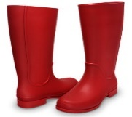
Big Red Boots
This Photo by Unknown Author is licensed under CC BY

Big red boots, big red boots.
One of them squeaks and the other one toots.
One of them hops and the other one stamps.
Big wet boots take long, wet tramps.

Boots, boots, big red boots.
One of them squeaks and the other one toots.

Big red boots on busy little feet
start out shiny, clean and neat.
Big red boots oh yes, yes, yes,
end up muddy in a terrible mess.

Boots, boots, big red boots.
One of them squeaks and the other one toots.

Boots, boots, big red boots,
squelch through mud and trample roots.
Big red boots say, “Look! Oh gosh!
What a great puddle there... Yay! SPLOSH!”

Reproduced by kind permission of Tony Mitton

