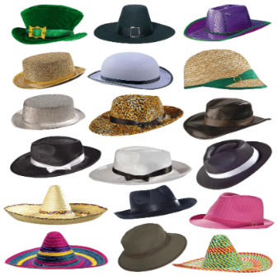
My Hat!

Here’s my hat.
It holds my head,
the thoughts I’ve had
and the things I’ve read.

It keeps out the wind.
It keeps off the rain.
It hugs my hair
and warms my brain.

There’s me below it,
the sky above it.
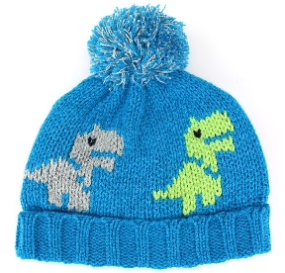
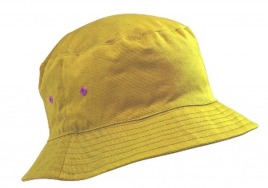
It’s my lid.
And I love it.

Reproduced by kind permission of Tony Mitton

