Year 5 Math
Understanding the short division method (bus stop)
Please follow the PowerPoint for instructions on how to use this method (which is new to some children).
This is in 3 levels of difficulty –you do not need to do all the questions- choose the difficulty that matches your confidence level. 3 is the hardest. Spend extra time today trying to feel really happy with short division.
https://www.bbc.co.uk/bitesize/topics/z36tyrd/articles/zgxdfcw
Use the link above for extra support with this method. You could even write out your own sums to help you practise.

Level 1
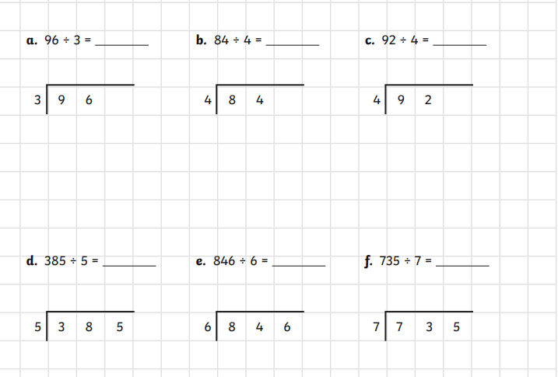

Level 2
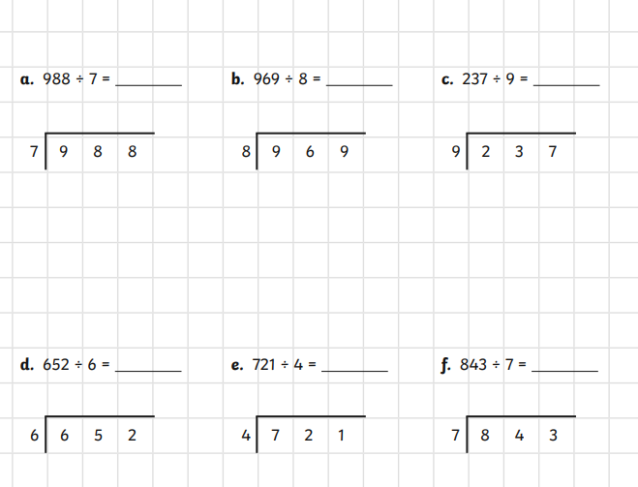

Level 3

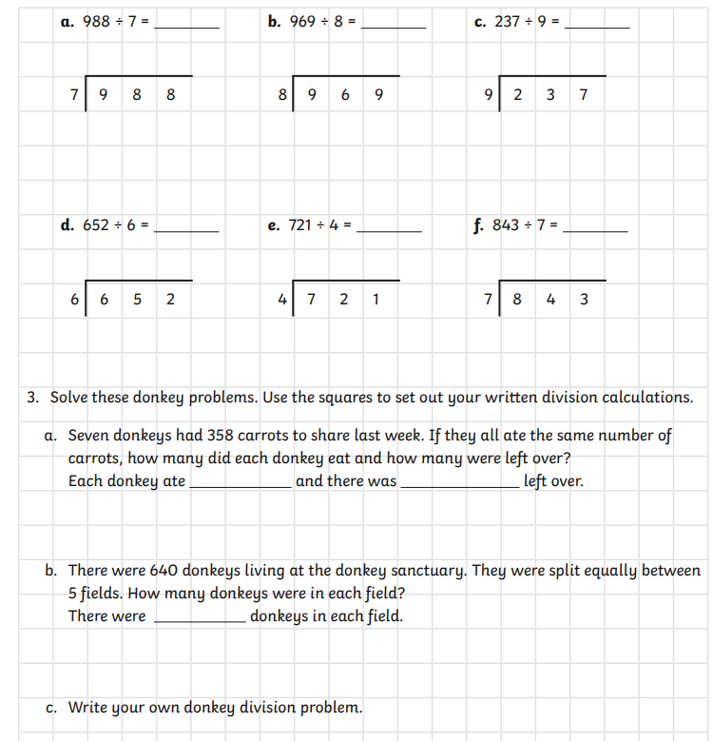
Challenge

Answers 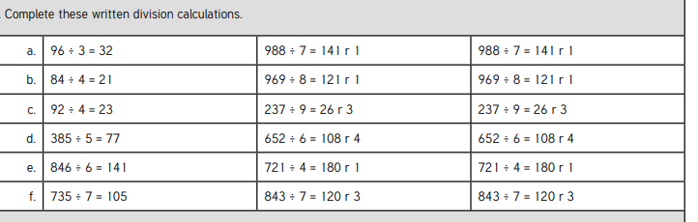
Level 1 Level 2 Level 3
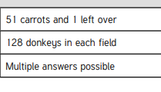
Level 3 Challenge
3 a
3b
3c

