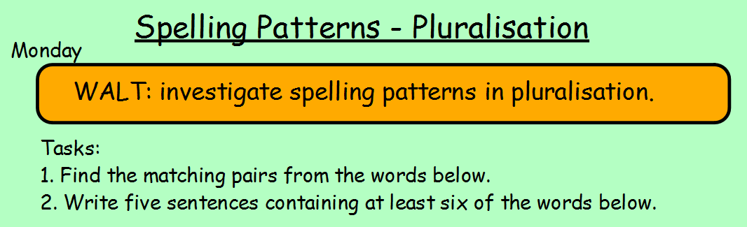belief wives puffs calf berry
dog brother babies fish dogs
house friend houses puppies
puff calves berries shelf
balloon fox baby balloons brothers
sister shelves friends fish sisters
foxes puppy beliefs curve wife

