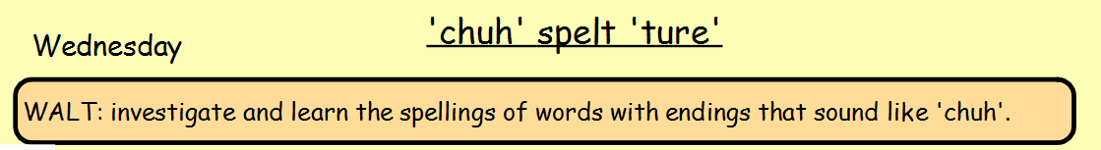
Today you are going to practise the following spellings so that you are ready for your test on Friday.
Words to learn:
mixture furniture **You can choose to learn these spellings
picture texture using your preferred method. See below
creature for some ideas:
adventure
departure
future
nature
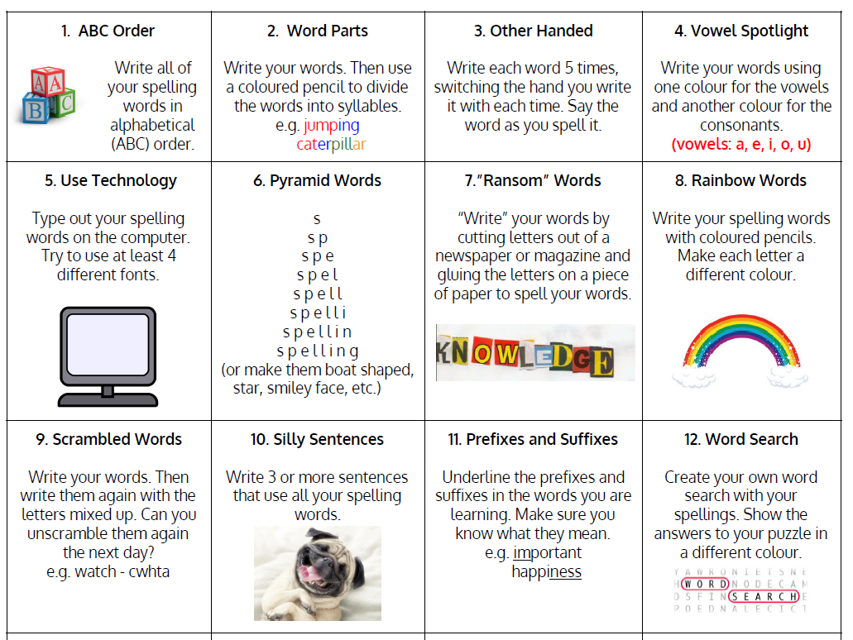
expenditure

