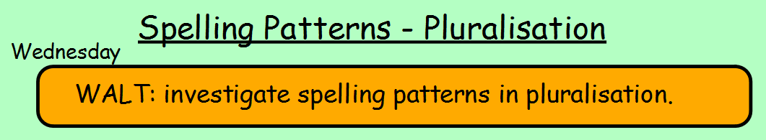
Today you are going to practise the following spellings so that you are ready for your test on Friday.
Words to learn:
berries thieves **You can choose to learn these spellings
babies sandwiches using your preferred method. See below
families for some ideas:
glasses
buzzes
monkeys
wives
wishes
