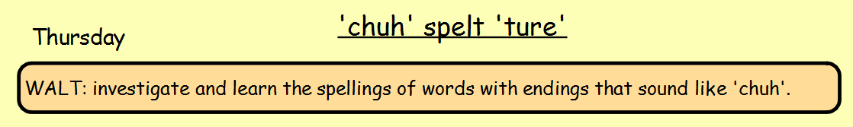
Tasks:
- Read and copy out the passage below. Insert the correct words in the gaps, look back at the words you have been learning so far this week and decide on which word goes in which gap.
The pirates set sail in search of _________. The horizon was a pretty _______. The sea was a sparkling _______ of blues and greens. However beneath its depths lay ________waiting for the _________of a ship - it loved the taste of human flesh.

- Write three of your own silly sentences containing any of the spelling words you have been focusing on this week. Could you draw a picture to go with it?

