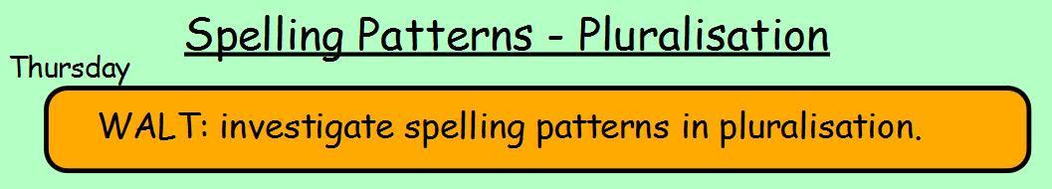
Tasks:
- Choose the correct spelling out of the choices below and write it down.
- Write six sentences where each sentence contains one of the words below.
- Draw a scene (picture) which shows the correct spelling words below in it.
