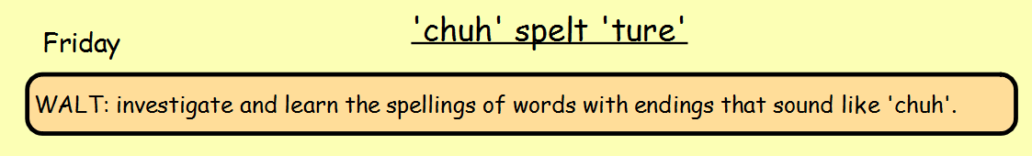
Are you ready for a test?
Ask a family member to test you on the words you have been investigating this week.
Send me a message on TEAMS to let me know your score.
mixture
furniture
picture
texture
creature
adventure
departure
future
nature
expenditure

