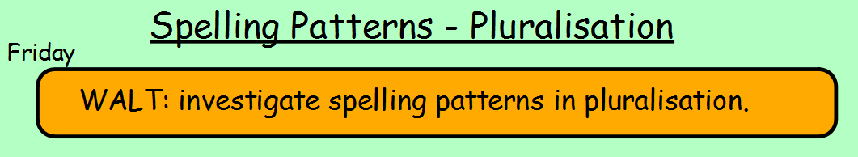
Are you ready for a test?
Ask a family member to test you on the words you have been investigating this week.
Send me a message on TEAMS to let me know your score.
berries
thieves
babies
sandwiches
families
glasses
buzzes
monkeys
wives
wishes

