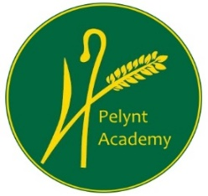
Pelynt Academy
Pelynt,
Looe,
Cornwall, PL13 2LG
Tel: 01503 220262
www.pelyntprimaryschool.co.uk
secretary@pelyntprimary.co.uk

Home Learning Class 1 - Week beginning 22nd February 2021
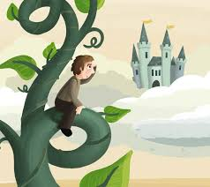
For the next two/three weeks our home learning is going to be based around the traditional tale ‘Jack and the Beanstalk’. For our literacy lessons we are going to be following the BBC English unit of work. This format will be familiar to the children as we used this when our learning was focussed on the story of Little Red Riding Hood. The story of Jack is told through 14 clips (we shall focus on one each day) and if there is a song to accompany a particular part of the story, I will direct you to it on the daily literacy plan.

This is the link to the videos of the story we shall be using each day: https://www.bbc.co.uk/teach/class-clips-video/english-ks1-jack-and-the-beanstalk-home/zff42sg but I will put a direct link for the episode you need on the plan for each day. There is one video a day and I will list or attach the resources you need for each lesson. Please use the direct links from the plan; it may become confusing between songs/videos/comprehension tasks otherwise. The lessons will need to be completed in order as they follow on from each other. There will continue to be a daily lesson sheet as previously for maths, phonics, handwriting and spelling learning activities. Please check this each day. Please note - children may need adult help with the writing tasks. Some tasks may be done in pictures if appropriate. I would expect Year 1 children to write each day, while tasks for Reception children will be more varied.

As before, after the Literacy based grid there is a curriculum grid with activities covering the other curriculum subjects/areas of learning.
For Year 1 children, we suggest you pick one to complete each afternoon but make sure you cover a range of subjects. As always, you can of course think of some of your own if you would like to.
Reception children can also choose from the curriculum grid if they wish to but please remember that learning through play is most important for the children at this age.
If you have any questions, please do not hesitate to contact me: jwakeham@pelyntprimary.co.uk

*Remember to send pictures of your learning so that I can provide feedback*

Literacy Learning Grid

Mon 22nd Feb | INSET DAY
Tues 23rd Feb | WALT: listen to part of a story  In this lesson we will listen to/watch the first part of the story; https://www.bbc.co.uk/teach/class-clips-video/english-ks1-jack-and-the-beanstalk-pt1/zjnc7nb Episode 1: What shall we do?  Year 1 – watch the beginning of the story, then sound out to write the things you would daydream of if you were Jack (see attached sheet).  Reception – use the attached sheet to create your own ‘silly shelves’. Jack had a pair of smelly socks on one shelf; what could you draw on your shelves? You may also choose to sound out to label your items.  Now listen to the tutorial for the song ‘What Shall we do?’ and join in to learn it: https://www.bbc.co.uk/teach/school-radio/music-jack-and-the-beanstalk-song1/z7m67nb
Wed 24th Feb | WALT: recall what happens in a story  In this lesson we will listen to/watch the second part of the story; https://www.bbc.co.uk/teach/class-clips-video/english-ks1-jack-and-the-beanstalk-pt2/z7ykxyc Episode 2: We have to sell Daisy  Now take the comprehension quiz for the first two episodes (scroll down to the bottom of this page): https://www.bbc.co.uk/teach/school-radio/music-jack-and-the-beanstalk-song1/z7m67nb  Year 1 – look at the pictures on the attached sheet. Talk about what is happening in each picture and then use your sentence prompts and sound mats to write a sentence for each picture.  Reception – use verbal sentences to tell a grown up what is happening in each picture on the attached sheet. Then look at the second sheet with a grown up. What is a pail? Can you think of other words with the ai digraph/sound in? Can you continue a rhyming string?
Thurs 25th Feb | WALT: describe a scene from a story  In this lesson we will listen to/watch the third part of the story; https://www.bbc.co.uk/teach/class-clips-video/english-ks1-jack-and-the-beanstalk-pt3/zdnc7nb Episode 3: Jack went to market  Year 1 – draw a scene from the market write some sentences to describe what can be seen.  Reception – play the memory game, saying, ‘I went to market and I saw…’ with some of your family. Use what you may have seen in the story. Each person takes a turn to add one more item each time and see how long you can keep adding objects and remembering what has been added to your list beforehand.  Now listen to the tutorial for the song ‘Jack went to market’ and join in to learn it: https://www.bbc.co.uk/teach/school-radio/music-jack-and-the-beanstalk-song2/zkhrbdm
Fri 26th Feb | WALT: recall what happens in a story  In this lesson we will listen to/watch the fourth part of the story; https://www.bbc.co.uk/teach/class-clips-video/english-ks1-jack-and-the-beanstalk-pt4/z642f4j Episode 4: Five Magic Beans  Now take the comprehension quiz for the first two episodes (scroll down to the bottom of this page):  https://www.bbc.co.uk/teach/school-radio/music-jack-and-the-beanstalk-song2/zkhrbdm  Year 1 – At the market, Jack spoke to lots of different people. Some asked him questions, while some made statements. Read the sentences on the attached sheet and decide if each one is a question or a statement. Add a question mark at the end if it is asking a question and put a full stop if it is a statement.  Reception – make your own magic beans (see the EAD activity below). Make sure you make 5!
Curriculum Learning Grid
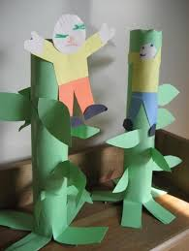  Art/design/ Expressive arts & design | WALT: make our own recycled beanstalk.  Can you make a beanstalk with cardboard tubes, paper or other recycled materials? Measure how tall it is once you’re finished. I wonder how tall you can build a beanstalk. You might want to have a competition at home and could use Lego or Duplo too!
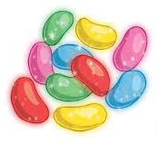 | WALT: use materials for a purpose.  Design your own magic beans using any materials you can find. You could use pens, paper, tin foil, buttons, string… anything to make your beans look magical!
WALT: use mixed media
Collect different materials to create your own beanstalk collage. You might use cotton wool for clouds, natural materials such as leaves, sticks, seeds, etc. you could create a background with pencils or paints. If you have watercolours paints you could use one of the techniques in this clip to create a wash for the background: https://www.youtube.com/watch?v=EepRMcteAUc
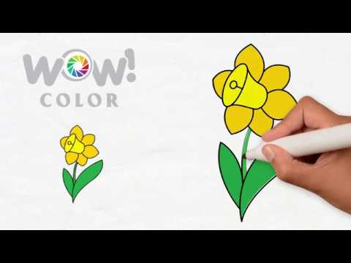 | WALT: use line and infill techniques  https://www.youtube.com/watch?v=svF94WVMFoc  Watch this video to learn how to draw a spring flower using lines and infill techniques to create a daffodil. You might infill with paint, pencil or crayon. Watch carefully! You may like to observe a real life daffodil for this too.
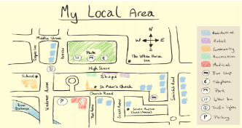  Geography/Understanding the world | WALT: draw a map  Draw a map of Jack’s village. Where is the Market? Jack’s house? Is there a river, a park or other houses? Where is the beanstalk…?  Year 1 children should label their map and you may want to design symbols for the features on your map. You could also create a map for the land of the giant.
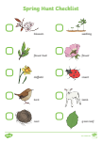 | WALT: recognise the four seasons and daily weather patterns  We talk about the seasons a lot at school; we are now very close to entering Spring; look at the ‘All About Spring’ power point and then tell a grown up what you have learnt about the four seasons. You may want to go on a spring hunt – you could just observe the signs of spring in nature around you or use the attached ‘Signs of Spring’ sheet. You may like to listen to Vivaldi’s Four Seasons and see if you can spot which piece represents each season:  https://www.youtube.com/watch?v=GRxofEmo3HA
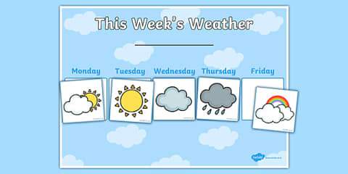 | WALT: recognise daily weather patterns  Now that spring is here, the weather may be changing. Can you make a daily weather chart and observe/record the weather each day? Your chart may look like the one here or you may choose your own design. You will need to design a symbol for each type of weather we may have. You could record the weather each day and discuss what you notice; which type of weather have we had most of? How many days per week do we have of rain/cloud/sunshine?
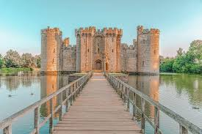  History/Understanding the world | WALT: Design a castle  Later in our story, we meet a character who lives in a castle; look at the attached ‘Castles information’ sheet which teaches you all about castles; you could then design/draw your own castle or use the ‘Parts of a castle’ sheet to label the parts of a castle you have learnt about.
Science/Understanding the world  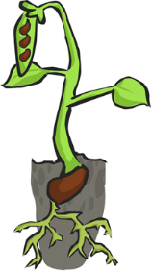 | WALT: carry out an experiment and observe what happens  Jack is given some magic beans. Ask someone in your family if they have any bean seeds which you could plant (you could try using any type of seed, if a bean is not available). Follow the instructions on the attached ‘Bean Experiment’ sheet to carry out a growing experiment (you may not be planting the bean in a way you might expect!). Then observe your bean and record what happens in the ‘Bean Plant Diary’. Draw pictures, label and write sentences as appropriate. The four things a seed needs to grow healthily is mentioned on the experiment sheet. What are they?
WALT: recognise the lifecycle of a plant and name parts
Once your bean experiment is complete and you have planted it into soil, complete the ’Bean Labelling’ sheet to show that you can order the lifecycle of a bean. Year 1 children should then label each part of the bean on the posters in that document. You could draw these pictures yourself if you prefer.
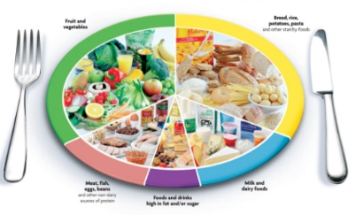 | WALT: design a healthy meal  Watch the BBC Teach video clip about ‘Keeping my body healthy’: https://www.bbc.co.uk/teach/class-clips-video/science-ks1-keeping-my-body-healthy/zk4dwty  Can you use a paper plate or a circle of paper/card to show the different food groups you need to keep healthy? You might want to draw, paint or collage the different foods in each section.
RE/Understanding the world  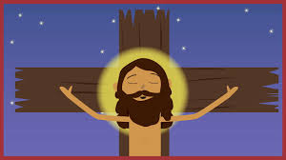 | WALT: understand why Easter is special for Christians  https://www.youtube.com/watch?v=Wnbo2AmS3OI Watch the Easter story here and discuss it with a grown up. Why do you think that Easter is a special time for Christians? Perhaps a grown up could jot down your thoughts/ideas.
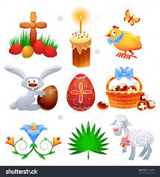 | WALT: recognise the symbols of Easter  Watch the ‘Symbols of Easter’ powerpoint. Then Year 1 children should make their own poster to show the different symbols. You should draw and write a sentence about each symbol too.  Reception children could play the ‘Easter Symbols Bingo’ which is attached.
Music/Expressive arts & design | WALT: learn a song  If you do not learn the songs as part of your literacy lesson each day, then you could follow this link: https://www.bbc.co.uk/teach/school-radio/music-jack-and-the-beanstalk-index/z7jq8xs  There are 7 songs from Jack and the Beanstalk to learn. You could pick a couple, or you could attempt to learn all of them! Each song comes with different resources including a tutorial video.
WALT: use musical words
Listen to the piece of music here: https://www.bbc.co.uk/teach/school-radio/music-jack-and-the-beanstalk-song1/z7m67nb
Scroll down to the ‘Listening music’ activity; this is the 3rd Movement from Flute Concerto in D Minor by CPE Bach. Can you identify any of the instruments in this piece? How about the solo instrument? Can you talk about the tempo with a grown up? Is the music fast or slow? Are the notes long and smooth or short and jumpy? Do you like/dislike this music? Why?
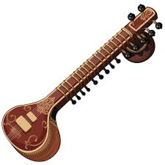 | WALT: find out about a musical instrument  Listen to the piece of music here: https://www.bbc.co.uk/teach/school-radio/music-jack-and-the-beanstalk-song2/zkhrbdm  - Scroll down to the ‘Listening music’ activity; this music is ‘Discovery of India’. It is from India is played by a famous musician called Ravi Shankar. Ravi is playing the sitar - a bit like a large guitar but with seven strings.  - There are lots of different rhythms playing at once. The main beat is played by small hand drums. Can you hear the different rhythms?  - Is the tone of the music happy or sad? Is it slow or fast? Why do you think it is good to use for this part of the story?  - Watch this video to see the many different parts of a sitar. Which instrument does it remind you of?  - https://www.youtube.com/watch?v=GL27Kcvnk5o
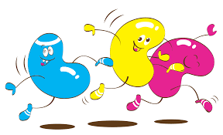  PE/Physical development | WALT: move our body in different ways.  Play the Beans game at home with your family to get your heart pumping. Everyone needs to move around the room whilst one person is going to call out the instructions below. When a type of bean is called out you need to do the corresponding action.  1. Runner Beans: Run around the room or on the spot  2. Broad Beans: Do a big, broad star shape  3. Baked Beans: Lie on the floor, like beans on toast  4. Kidney Beans: Make a curvy C-shape with your body  5. Butter Beans: Pretend the floor is slippery  6. Jumping Beans: Jump up and down  7. Human Beans: Dance around the room however you like!
 | Continue to choose a daily activity from our Activity Menu.
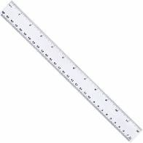  Maths | WALT: measure using non-standard and standard measurement  I am challenging you to measure your bean as it grows! You could use non-standard measurement to do this by using paperclips, pasta, pencils, anything at all to measure the height of your bean. I would like year 1 children to use a ruler/tape measure to measure in centimetres please; you may then wish to find different sized items around your house and order them according to size.  Try to use a ruler to measure their length. Find items that are longer or shorter than 30 cm in your house.
*PLEASE REMEMBER TO SEND ME PICTURES OF YOUR LEARNING EACH DAY – IT IS IMPORTANT SO THAT I CAN PROVIDE FEEDBACK*
There will be regular updates on our class blog but here are some useful links you might need for daily lessons at home:

Subject | Useful websites
English/Literacy | For phonics practice: https://www.phonicsplay.co.uk/ Phase 3, 4 & 5 games are suitable for Year1. Phase 2 & 3 for Reception.  For reading books: https://home.oxfordowl.co.uk/reading/free-ebooks/ You can find free e-books here which will match the book band colour which your child brings home from school (look on the back cover of their book).  Reading: https://www.teachyourmonstertoread.com/ Use your login to play the phonics/reading games.
Maths | Maths practice: https://www.topmarks.co.uk/maths-games Interactive games for practising the area of maths your child is learning about.
Other useful sites | Physical exercise activities from our PE partners, Arena: https://www.youtube.com/channel/UCCStjKlMICO-Em7zMJoHR3A  https://www.bbc.co.uk/bitesize BBC Bitesize is a great site for lessons in every area of learning – we may direct to certain lessons or they are great if your child would like some practice.  https://www.bbc.co.uk/programmes/p007g5y4 BBC Schools Radio is a great site for listening, songs, music and story activities.

