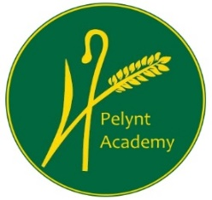
Pelynt Academy
Pelynt,
Looe,
Cornwall, PL13 2LG
Tel: 01503 220262
www.pelyntprimaryschool.co.uk
secretary@pelyntprimary.co.uk

Friday 26th February 2021
Maths:
YEAR 1: Today we are continuing to learning to count in 2’s. Click on the link below to view the video. Complete the year 1 maths worksheet.
https://vimeo.com/505658511
YEAR 2: Today we are learning to divide by 2. Click on the link below to view the video. Complete the Year 2 maths worksheet.
https://vimeo.com/498260506
Keep using tt rockstars to practice your times tables.

Phonics/Reading:
Year 1: Follow the link for the Year 1 phonics lesson. Today’s lesson is Year 1 Spring Term lesson 32 – oo/u pudding
https://www.youtube.com/watch?v=3NS-GQsFnj0
Follow the topic grid for your daily English lesson.
Please log in to your spelling shed account from the individual email that has been sent to you. There is an assignment that has been set for you this week.
Year 2:
Please follow the topic grid for your daily English lesson.
Please log in to your spelling shed account, from the individual email that has been sent to you. There is an assignment that has been set for you this week.

Both year groups, try to practice reading to an adult for at least 10 mins every day. See the reading websites below.
Practice your ‘teach your monster to read’ if you haven’t completed all of the levels.

Website hyperlinks to access reading resources:
https://library.thenational.academy/

https://www.vooks.com/

https://www.bbc.co.uk/bitesize/subjects/zgkw2hv

https://home.oxfordowl.co.uk/reading/free-ebooks/

Free Kid's eBooks and NOOK Books | Barnes & Noble® (barnesandnoble.com)

Phonics Games for the Classroom and Home - Phonics Bloom

Here is an additional website with some excellent reading resources for home learning:
https://www.worldbookday.com/

