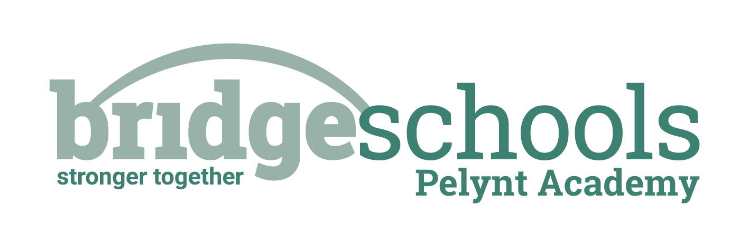
Pelynt Academy
Pelynt,
Looe,
Cornwall, PL13 2LG
Tel: 01503 220262
www.pelyntprimaryschool.co.uk
secretary@pelyntprimary.co.uk

RECEPTION
PHONICS: | https://www.youtube.com/watch?v=CtpqH2XtUc4  Lesson 32 – Read longer words  *Don’t forget to log in to Teach your Monster to Read too; I need to see that you have been practicing your reading/phonics.
MATHS LESSON: | https://whiterosemaths.com/homelearning/early-years/building-9-10-week-1/  Building 9 & 10 Session 3 – Representing & Sorting 9 & 10
MATHS ACTIVITY: | https://wrm-13b48.kxcdn.com/wp-content/uploads/2021/01/PDF-Building-9-10-Wk-1-Session-3-Ordering-Numerals-to-10.pdf Complete this activity or you could make your own set of numbers to 10 cards.
LITERACY: | See the Jack and the Beanstalk Home Learning Grid for today – each lesson is clearly dated. Enjoy the next part of the story and making your magic beans.
HANDWRITING: | We are continuing to work on the one-armed robot family of letters; today I would like you to write any of the one-armed robot letters which you need to practise. Remember to trace write the letter and words before writing your own to complete each line. Use a writing pencil if possible and sit correctly with your back into the chair and feet on the floor at a table. Always start writing the robot family of letters at the top.
TOPIC: | Look at the practical activities from the other areas of learning on the Jack and the Beanstalk Home Learning Grid if you would like further learning fun. PLEASE NOTE that the afternoon activities are not compulsory; it is important for children in Reception to learn through play at this stage.  Remember to keep active – you can choose different forms of exercise from the daily activity menu.
REMEMBER TO SEND ME PICTURES OF YOUR LEARNING PLEASE.

Class 1 Daily Home Learning THURSDAY 25th FEBRUARY 2021

YEAR 1
PHONICS: | https://www.youtube.com/watch?v=GU05ZzDnjb8&t=3s  Lesson 59: Review the week  *Don’t forget to log in to Teach your Monster to Read too; I need to see that you have been practicing your reading/phonics.
MATHS LESSON: | https://whiterosemaths.com/homelearning/year-1/spring-week-6-number-place-value-within-50/  Compare objects to 50
MATHS ACTIVITY: | You choose: Complete the activities on the attached sheet or use real life objects and the more than/less than/equal to symbols to make your own comparison number sentences.
LITERACY: | See the Jack and the Beanstalk Home Learning Grid for today – each lesson is clearly dated. Enjoy the next part of the story and today you are identifying questions and statements.
HANDWRITING: | We are continuing to work on the one-armed robot family of letters; today I would like you to write any of the one-armed robot letters which you need to practise. Remember to trace write the letter and words before writing your own to complete each line. Use a writing pencil if possible and sit correctly with your back into the chair and feet on the floor at a table. Always start writing the robot family of letters at the top.
SPELLINGS FOR THIS WEEK: | ask, pull, full, she, house, our  I have attached the spelling challenge sheet to help you practice, if you would like it. Please ask a grown up to test you today.
TOPIC: | Look at the learning activities from the other areas of the national curriculum on the Jack and the Beanstalk Learning Grid – we would like you to choose at least one activity per day please, from across the different subjects.  Remember to keep active – you can choose different forms of exercise from the daily activity menu.
REMEMBER TO SEND ME PICTURES OF YOUR LEARNING PLEASE.THIS IS IMPORTANT SO THAT I CAN SEE WHAT YOU ARE LEARNING AND PROVIDE FEEDBACK.

