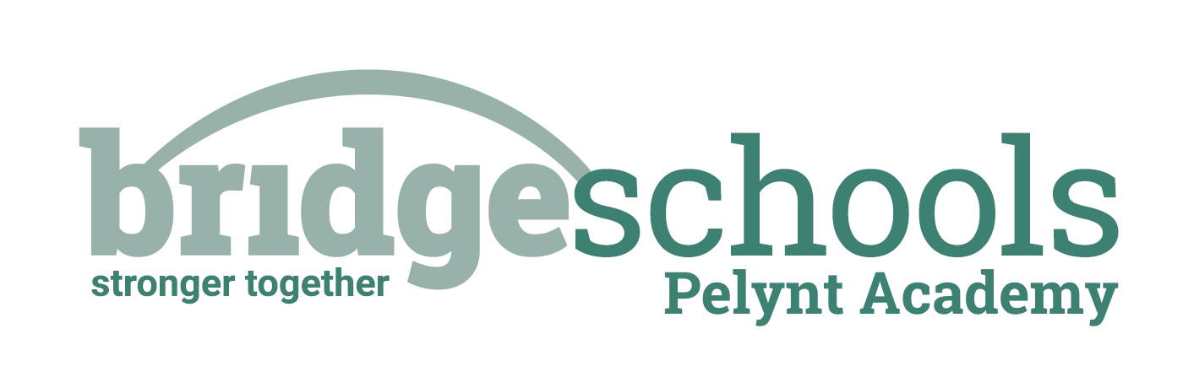
Pelynt Academy
Pelynt,
Looe,
Cornwall, PL13 2LG
Tel: 01503 220262
www.pelyntprimaryschool.co.uk
secretary@pelyntprimary.co.uk

RECEPTION
PHONICS: | https://www.youtube.com/watch?v=jGlx3LA2CZ8  Lesson 33 – Read longer words  *Don’t forget to log in to Teach your Monster to Read too; I need to see that you have been practicing your reading/phonics.
MATHS LESSON: | https://whiterosemaths.com/homelearning/early-years/building-9-10-week-1/  Building 9 & 10 Session 4 – Composition of 9 & 10
MATHS ACTIVITY: | https://wrm-13b48.kxcdn.com/wp-content/uploads/2021/01/PDF-Building-9-10-Wk-1-Session-4-Composition-of-9-and-10.pdf Complete this activity or you could explore the different ways to make/show 10 using 10 counters or objects from home.
LITERACY: | See the Jack and the Beanstalk Home Learning Grid for today – each lesson is clearly dated. Enjoy the next part of the story and answer some questions about what happens.
HANDWRITING: | We are starting to write zig-zag letters today, starting with ‘v’. Remember to trace write the letter and words before writing your own to complete each line. Use a writing pencil if possible and sit correctly with your back into the chair and feet on the floor at a table. Always take care to make sure that zig-zag letters have straight lines and sharp corners.
TOPIC: | Look at the practical activities from the other areas of learning on the Jack and the Beanstalk Home Learning Grid if you would like further learning fun. PLEASE NOTE that the afternoon activities are not compulsory; it is important for children in Reception to learn through play at this stage.  Remember to keep active – you can choose different forms of exercise from the daily activity menu.
REMEMBER TO SEND ME PICTURES OF YOUR LEARNING PLEASE.

Class 1 Daily Home Learning MONDAY 1st MARCH 2021

YEAR 1
PHONICS: | https://www.youtube.com/watch?v=L4Z34zid4XU&t=7s  Lesson 60: Review the week  *Don’t forget to log in to Teach your Monster to Read too; I need to see that you have been practicing your reading/phonics.
MATHS LESSON: | https://whiterosemaths.com/homelearning/year-1/spring-week-6-number-place-value-within-50/  Compare numbers within 50
MATHS ACTIVITY: | You choose: Complete the activities on the attached sheet or use real life objects and the more than/less than/equal to symbols to make your own comparison number sentences. I have attached your 1-50 grid again, if you need it to help.
LITERACY: | See the Jack and the Beanstalk Home Learning Grid for today – each lesson is clearly dated. Enjoy the next part of the story and answer some questions about what happens.
HANDWRITING: | We are starting to write zig-zag letters today, starting with ‘v’. Remember to trace write the letter and words before writing your own to complete each line. Use a writing pencil if possible and sit correctly with your back into the chair and feet on the floor at a table. Always take care to make sure that zig-zag letters have straight lines and sharp corners.
SPELLINGS FOR THIS WEEK: | he, put, friend, school, push, me  I have attached the spelling challenge sheet to help you practice, if you would like it. Please ask a grown up to test you on Friday.
TOPIC: | Look at the learning activities from the other areas of the national curriculum on the Jack and the Beanstalk Learning Grid – we would like you to choose at least one activity per day please, from across the different subjects.  Remember to keep active – you can choose different forms of exercise from the daily activity menu.
REMEMBER TO SEND ME PICTURES OF YOUR LEARNING PLEASE.THIS IS IMPORTANT SO THAT I CAN SEE WHAT YOU ARE LEARNING AND PROVIDE FEEDBACK.

