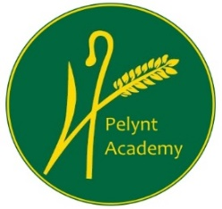
Pelynt Academy
Pelynt,
Looe,
Cornwall, PL13 2LG
Tel: 01503 220262
www.pelyntprimaryschool.co.uk
secretary@pelyntprimary.co.uk

Thursday 4th March 2021
Maths:
YEAR 1: Today we are learning to compare lengths. Click on the link below to view the video and complete the Year 1 maths worksheet.
https://vimeo.com/507433257
YEAR 2: Today we are learning to divide by 10. Click on the link below to watch the video and complete the Year 2 maths worksheet.
https://vimeo.com/498262386
Keep using tt rockstars to practice your times tables.

Phonics/Reading:
Year 1: Follow the link for the Year 1 phonics lesson. Today’s lesson is Year 1 Spring Term lesson 36 – ch/tch
https://www.youtube.com/watch?v=5M1ZpCN7O-4
Follow the topic grid for your daily English lesson.
Log in to your spelling shed account. There is an assignment that has been set for you this week.
Year 2:
Please follow the topic grid for your daily English lesson.
Log into your spelling shed account. There is an assignment that has been set for you this week.

Both year groups, try to practice reading to an adult for at least 10 mins every day. See the reading websites below.
Practice your ‘teach your monster to read’ if you haven’t completed all of the levels.

Website hyperlinks to access reading resources:
https://library.thenational.academy/

https://www.vooks.com/

https://www.bbc.co.uk/bitesize/subjects/zgkw2hv

https://home.oxfordowl.co.uk/reading/free-ebooks/

Free Kid's eBooks and NOOK Books | Barnes & Noble® (barnesandnoble.com)

Phonics Games for the Classroom and Home - Phonics Bloom

https://www.worldbookday.com/

