[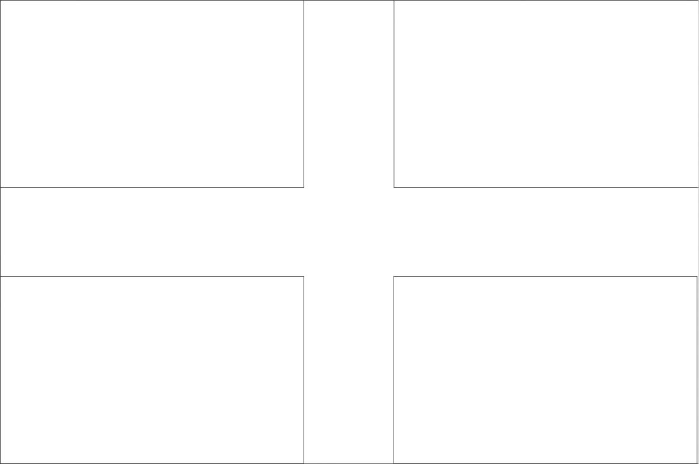](http://www.google.com/url?sa=i&rct=j&q=&esrc=s&source=images&cd=&cad=rja&uact=8&ved=2ahUKEwj2v9ucuungAhWLnxQKHTQQDuMQjRx6BAgBEAU&url=http%3A%2F%2Fwww.world-free-printable-flags.com%2Fworld-flags-coloring-pages1.html&psig=AOvVaw37qy3WGZL1vDelKwgTghhc&ust=1551822141018847)

[](http://www.google.com/url?sa=i&rct=j&q=&esrc=s&source=images&cd=&cad=rja&uact=8&ved=2ahUKEwj2v9ucuungAhWLnxQKHTQQDuMQjRx6BAgBEAU&url=http%3A%2F%2Fwww.world-free-printable-flags.com%2Fworld-flags-coloring-pages1.html&psig=AOvVaw37qy3WGZL1vDelKwgTghhc&ust=1551822141018847)

[](https://www.google.co.uk/url?sa=i&rct=j&q=&esrc=s&source=images&cd=&cad=rja&uact=8&ved=0ahUKEwja0_P5mb_SAhXMthoKHWKSA2EQjRwIBw&url=https%3A%2F%2Fen.wikipedia.org%2Fwiki%2FSaint_Piran's_Flag&psig=AFQjCNEBVGqqeO1mz6u_VS91fjTtFvtERA&ust=1488797742195865)

[](https://www.google.co.uk/url?sa=i&rct=j&q=&esrc=s&source=images&cd=&cad=rja&uact=8&ved=0ahUKEwja0_P5mb_SAhXMthoKHWKSA2EQjRwIBw&url=https%3A%2F%2Fen.wikipedia.org%2Fwiki%2FSaint_Piran's_Flag&psig=AFQjCNEBVGqqeO1mz6u_VS91fjTtFvtERA&ust=1488797742195865)