St Piran’s Day 5th March 2021
Design a pasty - Cornish miners used to have something savoury in one end of their pasty and something sweet in the other to keep them going during a long day down the tin mine. What would you put in yours? Draw your choice in each side of the pasty.
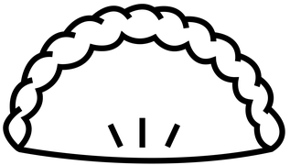
My savoury filling is ___________________________________________________
My sweet filling is_____________________________________________________

