The Colours of Cornwall Poetry
This is the Cornish tartan. It is a fabric which is woven from different coloured threads which all represent something associated with Cornwall:
Black and gold – for the ancient kings of Cornwall
White – the tin found in Cornwall
Blue – the sea
Red – the chough’s beak
You should use the ‘Colours of Cornwall List’ sheet to think of words which you associate to each colour and then use the poem frame below to write a poem called ‘The Colours of Cornwall’. To give you some ideas, I have included an example of a poem written by some children at our school several years ago.
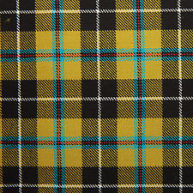People often wear a kilt made of Cornish tartan to special occasions such as weddings.
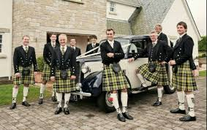
The Colours of Cornwall (example)
Black is the dark shadows that appear in night.
Black is rocks that lay on grass in front of the beach.
Black is night – the time I sleep.

White is clouds that fly through the sky and through the air.
White is a shooting star going around in circles.
White is a bunny that hops across a field.

Yellow is the sun that shines over the world.
Yellow is the sand that covers the beach.
Yellow is daffodils and buttercups that grow in my garden.

Red is the sunset in the afternoon.
Red is roses and poppies that grow in the soil.
Red is the fire that warms me up at night.

Blue is blueberries I pick in the afternoon for a delicious lunch.
Blue is the sky right above the clouds and my head.
Blue is bluebells I got for Mother’s Day.

The Colours of Cornwall
Black is_________________________________________________________
________________________________________________________________
________________________________________________________________
________________________________________________________________
White is ________________________________________________________
________________________________________________________________
________________________________________________________________
________________________________________________________________
Yellow is________________________________________________________
________________________________________________________________
________________________________________________________________
________________________________________________________________
Red is __________________________________________________________
________________________________________________________________
________________________________________________________________
________________________________________________________________
Blue is __________________________________________________________
________________________________________________________________
________________________________________________________________
________________________________________________________________

